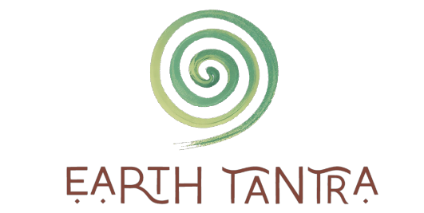
Practitioner Program Application 300 hrs
Thank you for the desire of applying to become an Earth Tantra 300 Hr Practitioner Student! You are encouraged to take your time and answer from the heart. Do your best to release any thoughts of HOW you think you should answer a question. Relax, take your time, have fun, and express your truth.
Process:
- Please return this application to tara@earthtantra.com
- Tara will review the applications on a first come first serve basis.
- She will respond within 3 to 10 business days. Applying doesn’t mean you are automatically accepted but considered.
- You’ll receive an email for either a follow up 30 minute zoom call or further written questions, other consideration or possibly acceptance. The chances of automatically being accepted for the 100 hr program are much higher if you’ve already scheduled a discovery session with Tara. Priority for the 300 hr certification program are for students who have already attended an online course or in person event or have scheduled a discovery session already.
- Upon acceptance, you’ll have 2 weeks to decide if you’d like to commit and sign the agreement.
- Once signed, we will begin our program with a zoom welcome ceremony and 1st one on one virtual check in.

APPLICATION
Everything shared in this application is confidential.

Name:
Home town/state/country:
Phone:
E-mail:
Birth Year:
Astrological Sign (sun/ moon – whatever feels best to share):

How did you originally find Earth Tantra?

Are you applying for the 100 hr practitioner online program OR 300 hrs Mentorship & practitioner online and in person program OR both?

Do you identify more masculine (Shiva) or feminine (Shakti) or 50/50 (not gender but energy)?

What is your current career or education path?

Emergency Name, Phone Number and relationship:

What Earth Tantra events and private sessions have you attended? Please list all:

Please list any highly impactful Tantra or other spiritual events you’ve attended:

What degrees, trainings and certifications do you hold (it doesn’t have to be spiritual)?

Describe your spiritual beliefs (short version is just fine)?

What are some of your strengths?

What are some of your challenges?

What is your relationship with mother earth?

Describe an experience when you’ve felt mother earth intimately? What did you physically, emotionally and energetically feel?

Have you ever had an experience when you’ve felt fearful of mother earth or an element (fire, earth, water or air)? Please describe.

What draws you to Tantra and what does Tantra mean to you?

What are your passions?

What are some of your daily, weekly, monthly and/or annual practices and rituals – if not developed yet, that’s okay? Please be honest.

What shadows, shame or trauma are you currently moving through in your spiritual journey?

What are you hoping to get out of this program?

What else would you like to tell us?

Health:
Do you have any physical limitations for us to consider?

Have you ever been diagnosed with a challenge or disease for the body or mind (heart disease, ADHD, diabetes, restless leg syndrome, depression, etc). If so, when and what adaptations do you seek if any?

Anything else we could be aware of to best support you and your learning, attention and heart style?

Please read and type your signature below.
I have read and understand this application. The answers shared are to the best of my knowledge and with integrity. I also understand that submitting this application doesn’t automatically accept me into the practitioner program. _____________________________________

